Slurry wizard user guide
Contents
Before you start 1
The headings below refer to the tab titles in the slurry wizard Excel file:
Guidance sheet 2
1. Slurry data entry 4
2. Livestock data entry 10
3. Slurry report 11
More about slurry on the AHDB website 13

Before you start
Before using the slurry wizard calculator, read the notes and disclaimer:

Check computer requirements
Note that the wizard will only function correctly if you have Microsoft Excel installed.
The slurry wizard is about 38 MB; please ensure you have enough disk space before downloading it.

Rainfall data
The slurry wizard contains rainfall data supplied by UK Centre for Ecology and Hydrology.

What livestock can it be used for?
The slurry wizard can be used for:
- all livestock which produce slurry to calculate slurry storage capacity requirements
- non-slurry-producing livestock to calculate N loading per hectare for NVZ compliance

What legislation applies to your farm?
Regulations vary by country. AHDB recommends finding out which legislation may affect your farm. The key ones are:
- Nitrate Vulnerable Zones (England)
- Nitrate Vulnerable Zones (Scotland)
- Farming Rules for Water (England)
- Storing silage, slurry and agricultural fuel oil (England, Scotland and Wales)
- The Water Resources (Control of Agricultural Pollution) regulations (Wales)

Disclaimer
Calculations carried out using this tool will be based on figures provided by the user. AHDB cannot take responsibility for decisions made as a result:
- All warranties, conditions and other terms implied by statute or common law are excluded to the maximum extent permitted by applicable laws. Unless expressly provided, this calculator and the information or results provided from your use of the calculator (“Results”) are delivered “as is” without warranty of any kind.
- We do not warrant or guarantee that the Results will be delivered free of any inaccuracies, omissions or errors (“Faults”), or that all Faults will be corrected.
- We shall not be liable for any loss, damage or cost resulting from any such Faults. You assume sole responsibility and entire risk as to the suitability and results obtained from use of the calculator, and any decisions made, or actions taken, based on the information contained in or generated by the calculator.

Copyright
Copyright Agriculture and Horticulture Development Board 2023. All rights reserved. No part of this publication may be reproduced in any material form (including by photocopy or storage in any medium by electronic means) or any copy or adaptation stored, published or distributed (by physical, electronic or other means) without the prior permission in writing of the Agriculture and Horticulture Development Board, other than by reproduction in an unmodified form for the sole purpose of use as an information resource when the Agriculture and Horticulture Development Board is clearly acknowledged as the source, or in accordance with the provisions of the Copyright, Designs and Patents Act 1988.
All other trademarks, logos and brand names contained in this publication are the trademarks of their respective holders. No rights are granted without the prior written permission of the relevant owners.

The headings below refer to the tab titles in the slurry wizard.

Guidance sheet

Welcome to the slurry wizard
The main aim of the slurry wizard is to identify whether there is adequate slurry storage and to explore different strategies to comply with regulations.
The slurry wizard has four functions:
- Calculates the existing slurry capacity.
- Calculates the existing slurry production.
- Generates a report to look at the monthly production compared to existing storage.
- Calculates the nitrogen produced in organic manures per hectare.
The slurry wizard includes the typical costs of slurry storage and associated operating costs for slurry spreading. If you wish, you can change some of the operating costs and the capital costs to refine the report for your own farm situation using your own figures.

Getting started
Download the slurry wizard and save it to your hard drive. Always save any versions created with a new file name (such as one for each farm or scenario) so that you can go back to the original version if needed.
On opening the slurry wizard, you will see the screen below:
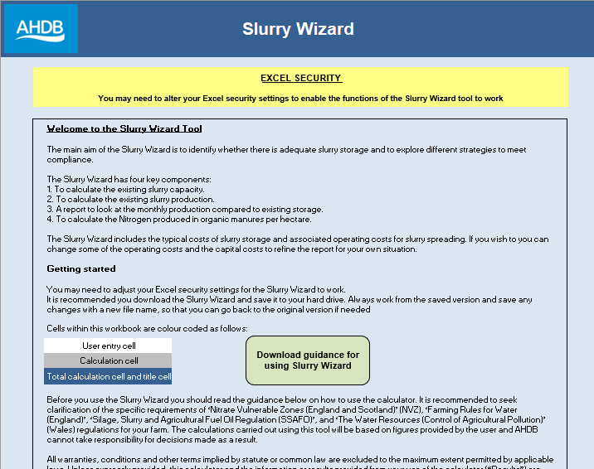

When you open the slurry wizard or try to run a macro, you may get the security warning below.
- Select Enable Content.
- In the Security Warning dialog, select Yes to make the document trusted.
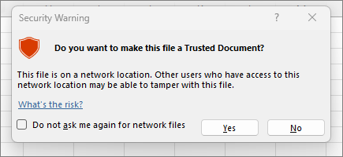
The wizard is now ready for your data to be entered.

1. Slurry data entry
Click on the Slurry Data Entry tab at the bottom of the screen.

Baseline farm data
Enter your own farm data in the white boxes in the first six rows.
‘Total farmable area’ is used to calculate the farm nitrogen loading.
‘Slurry store’ Use the 10-figure grid refence of the centre of the slurry store. This is used to select the relevant monthly rainfall data for your location. You can find a UK national grid reference at the UK Grid Reference Finder by right-clicking on the map at the centre of your slurry store.
‘Cattle in herd/pig herd size’ should include all farm animals (not just the milking cows) on the farm. The pre-populated cells represent typical values. Farm-specific values can be entered if these are available, but be aware that changing the depreciation rates could have a large impact on your results.
Purposes of collecting the data:
- The ‘Cows in milk’ figure is used to calculate the volume of parlour washings
- The depreciation and interest rates are used to look at the cost of new investment
- The ‘Water cost’ is used to calculate the benefit of harvesting roof water
- The ‘Slurry spreading cost’ is used to calculate the benefit of reduced slurry production
- The cost of water storage, water diversion, roofing cost and slurry storage are used in calculating the cost: benefit of slurry production/storage options
- It is very important for you to review the costs which might apply to your farm

Slurry storage capacity for earth bank stores
For earth bank stores, you need to enter the total depth (do not deduct 0.75 metres of ‘freeboard’), the width, the length and a slope of the sides.
You can see the options for Bank slope by clicking in the relevant cell and then choosing the appropriate one from the drop-down box to the right:
- 1:0.5 or 63º
- 1:0.75 or 53º
- 1:1 or 45º
- 1:1.5 or 33.7º
- 1:2 or 26.5º
- 1:2.5 or 21.8º
Enter your farm’s details in the white boxes. There is the option to include up to 10 earth-banked lagoons.
If your earth bank store has an impermeable cover, tick the relevant box in the column labelled ‘Tick if Covered Store’.
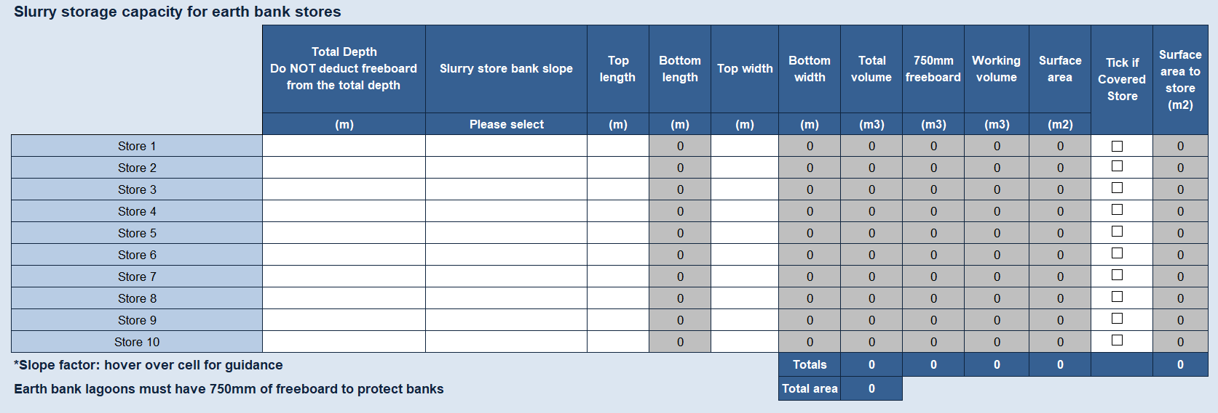

Slurry storage capacity for rectangular and circular tower stores
For rectangular and circular tower stores, deduct 0.3 metres of ‘freeboard’ from the height of the store to provide adequate capacity, as required by legislation.
- Enter your farm’s details in the white boxes. There is the option to include up to 10 rectangular stores and 5 circular tower stores. Insert the circumference of circular stores in meters and this will work out the diameter in meters. This needs to be the internal measurements of the tank or tower. For example, 100 m circumference is equivalent to 31.8 m diameter; 150 m circumference is equivalent to 47.7 m diameter.
- If your concrete or steel store has an impermeable cover, tick the box in the column ‘Tick if Covered Store’ to exclude rainwater falling onto the store from the slurry volume calculation.

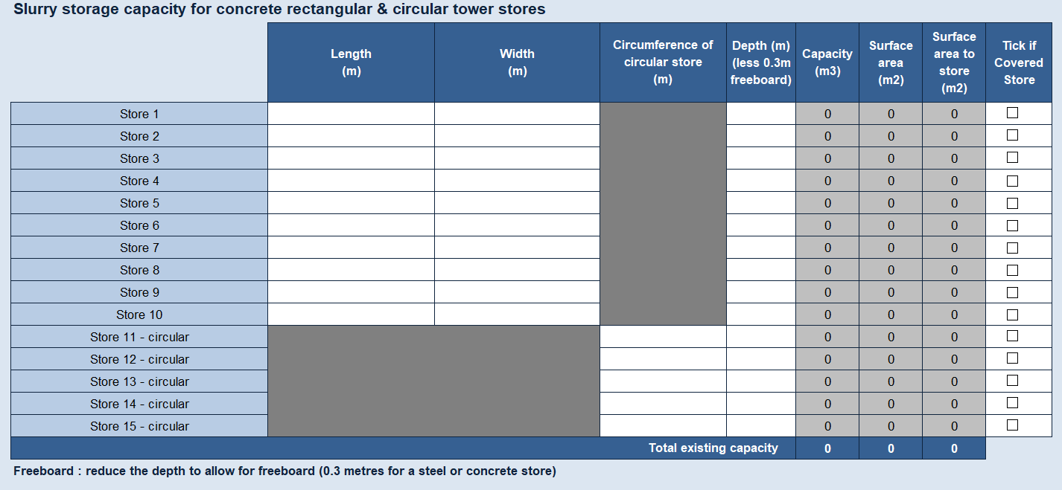
You must make a separate entry for circular stores (using cells Store 11 to Store 15) to allow the correct calculation of the capacity and the area.

Slurry storage capacity for slurry bags
Please enter the volume of any bags in m³. There is the option to include up to 10 slurry bags.
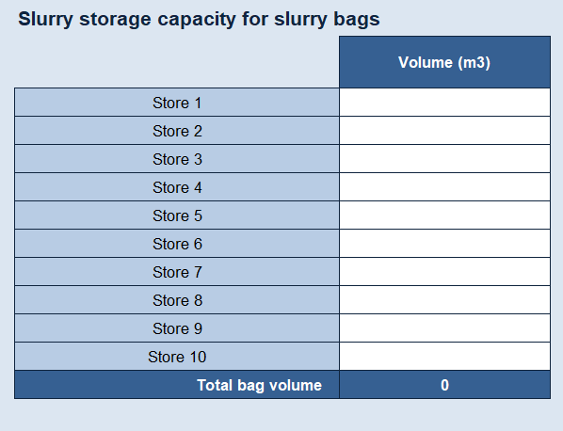
The total slurry storage capacity is copied through to the report so that you can see how this compares with monthly slurry production.

Slurry separator
You can use slurry separators to further reduce pressure on your stores once you meet legal minimum standards. When calculating whether you meet the legal minimum standards without a separator, select ‘No’ from the drop-down menu in the box.
If you have a slurry separator, select ‘Yes’ from the drop-down menu in the box. Assuming it is used to separate all the slurry produced on the farm and entering the store(s), please insert an appropriate ‘% reduction in slurry’.
You should refer to the separator manufacturer’s guidance. Typically, the value is 25%, with the range from 15% to 35%. You need to be realistic about the reduction in volume achieved to avoid wrongly calculating the volume of storage required.
If not all of your slurry goes to the separator before it goes to store, please reflect this using an adjustment to the ‘% reduction in slurry’ figure.
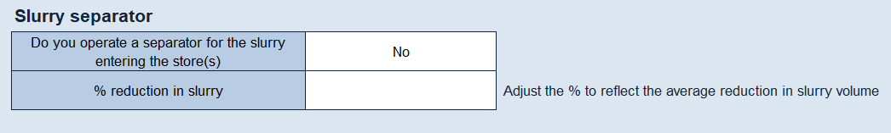
In England, you must have enough storage to meet the following requirements without a separator. This will make sure you have enough storage if the separator fails or needs maintenance.
All farms that produce slurry and spread it on their land must have at least enough storage to hold all the slurry produced in any four-month period and comply with SSAFO regulations.
If your farm is in a Nitrate Vulnerable Zone (NVZ), you need at least:
- Five months of slurry storage for cattle, sheep, goats, deer and horses
- Six months of slurry storage for pigs and poultry
The Farming Rules for Water require slurry to be spread only when a soil or crop requirement can be demonstrated.

Parlour washings to slurry store
The slurry wizard allows you to calculate the amount of water from parlour washing.
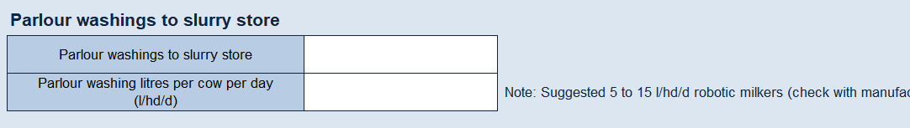
To include parlour washings going to slurry store, select ‘Yes’ from drop-down menu and then enter the volume of washings expressed as litres per cow per day, which will normally be between 20 (low volume washing) and 30 (high volume washing).
Farms using robotic milkers are advised to check with the manufacturer and enter a representative figure based on frequency of milking and performance of machine, usually between 5 to 15 l/hd/d.
The total monthly volume of parlour washings will then be calculated and copied through to the report.
If this water does not go into the main slurry store, select ‘No’ from the drop-down menu in the box.
Parlour washings are defined as slurry in England under the Water Resources (Control of Pollution) (Silage, Slurry, and Agricultural Fuel Oil) Regulations 2010 (SSAFO). If the washings do not enter the main slurry store, they must still be stored and handled as slurry.
When planning new storage, you should include the parlour washings in the calculation of your total storage capacity requirements. If you store your parlour washings separately from the main slurry store under SSAFO, you should provide a minimum of four months storage for it.

Pig wash water production
The slurry wizard allows you to calculate the volume of pig wash water that contributes to your slurry production. Please indicate if you wash down by selecting ‘Yes’ in the top input box.
You can choose to use either pre-set NVZ standard wash water values by selecting ‘Yes’ in the bottom box, or you can input your own figures by selecting ‘No – use own value for each animal type’. If you choose to input your own data, you must complete the column against each category of pig kept and expressed as litres/place/day.
Alternatively, you can choose to use your own daily total value by selecting ‘No – use own total daily value’ and enter a figure in User Entry Value Wash Water Total in litres/day.
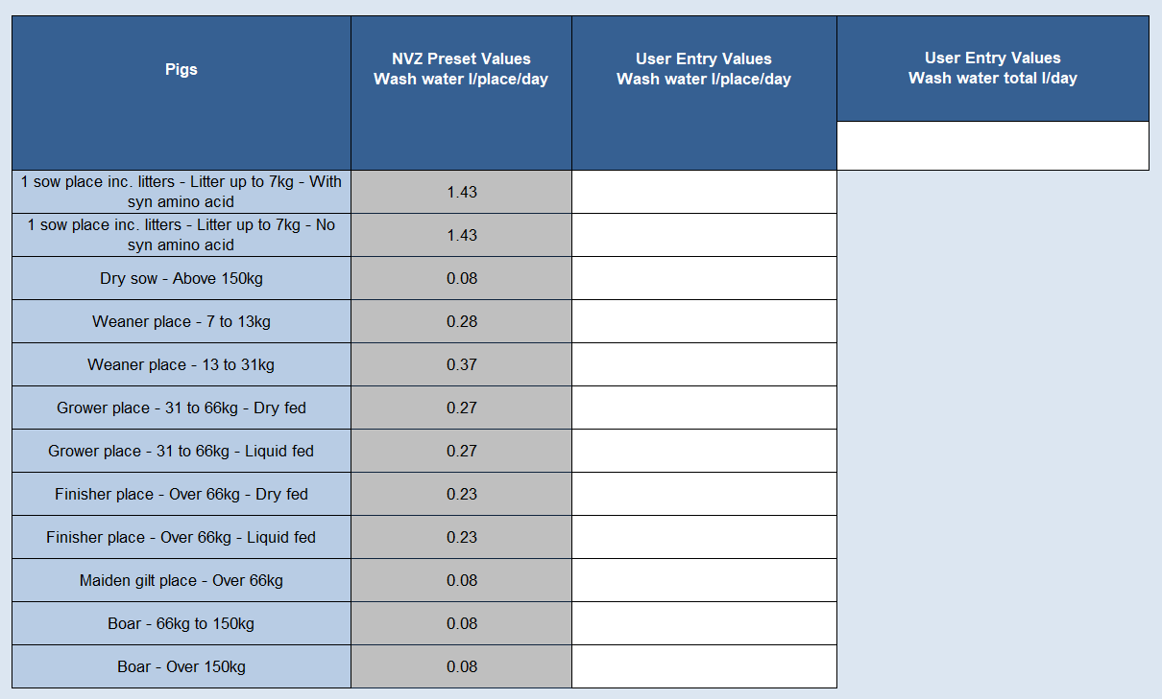

Uncovered areas of dirty yards, silage silos and earth bank surround to slurry store
There are many sources of slurry from uncovered yards, e.g. feed areas, collecting yards, silage clamps and loafing areas.
- Enter your farm’s details in the white boxes; there is the option to include up to 20 areas
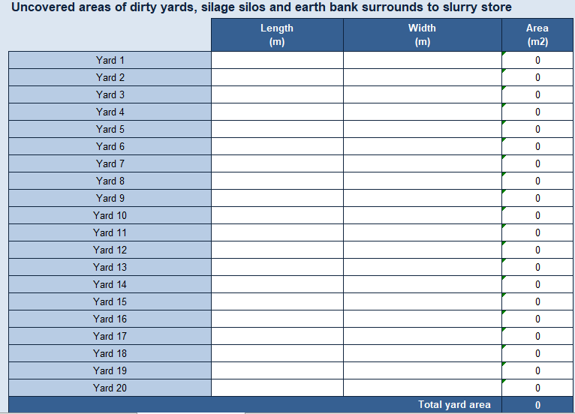
The slurry wizard allows you to include all the areas that drain to the slurry store. You must include clean yards that drain to the slurry store, area of silage pits if the rainfall they intercept drains to the slurry store, and earth-banked surrounds to stores as well as dirty yard areas. The total area is copied through to the report.
Irregular shaped areas can be entered as a total area in m².

Roof water area to slurry store
Roof water which drains into the slurry store can significantly increase the volume of slurry. You will need to look at all roofs around the unit and determine where the roof water drains to. If the water drains to the slurry store, then include this in the table. The area of the roof should be based on the floor area covered by the roof.
- Enter your farm’s details in the white boxes; there is the option to include up to 15 areas of roof. If there are more than 15 roof areas that go to store then you will need to amalgamate
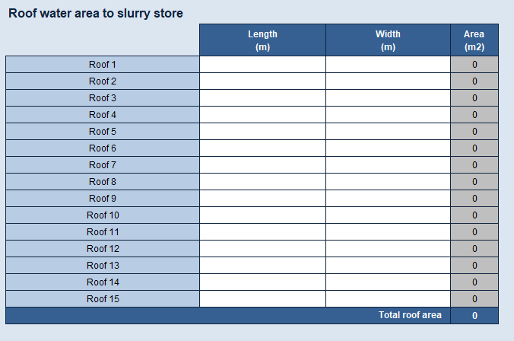
Once you have completed all the sections on this page, click on ‘Livestock Data Entry’ tab at the bottom of the page.

2. Livestock data entry
The slurry wizard allows you to enter all livestock on the farm to provide a farm nitrogen loading calculation and to calculate the amount of slurry produced.
Your farm’s nitrogen loading figure is calculated by dividing the total nitrogen output by the farmable area. However, this figure does not take in to account any export/import of manure.
You should consider the farm nitrogen loading in relation to the requirement for Nitrogen Vulnerable Zones (NVZ) and The Water Resources (Control of Agricultural Pollution) (Wales) regulations and/or Cross Compliance. Your farm’s nitrogen loading result will appear at the top of the Slurry Report page once you have entered all the data.
The Livestock data entry includes cattle, pigs and then all other livestock types that usually produce excreta to enable calculation of the N loading figure.
An example is shown below:
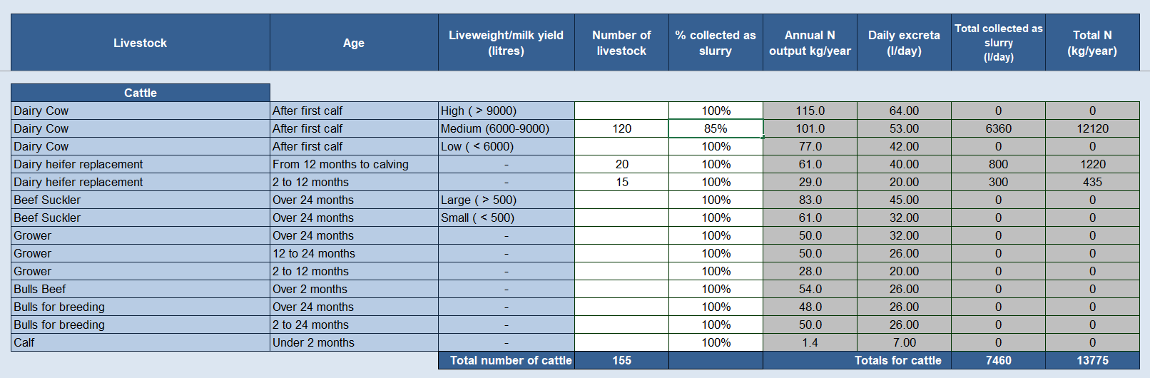

- Enter the annual average number of livestock into the white boxes in each category
- Enter the % collected as slurry in the white boxes in each category, e.g. in the example above, there are 120 cows in the milking herd, but with dry cows housed on straw, the amount collected as slurry is reduced to 85%. Where livestock are housed in a building that includes a straw bedded area and scrape passages, set the % collected as slurry to 50%; set as 0% where the floor is completely bedded
Once you have completed this section, scroll to the bottom of the page and click on the ‘Slurry Report’ tab.

3. Slurry report
The slurry report details the farm nitrogen loading based on the N produced in excreta by all animals on the farm divided by total farmed area, excluding any import/export of manures.
The following action points are highlighted:
- Number of months of storage
- Maximum likely two-day rainfall
- Recommended reception pit size
- Farming Rules for Water recommendation
- Roof water collection recommendation
- Slurry store cover recommendation
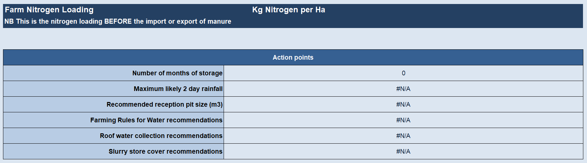
The ‘% excreta to store’ values are separated for cattle, pigs and other livestock. The values are set to 100% by default and will need to be adjusted accordingly for each month.
For cattle, if the cows are inside for the entire month, this would be 100%. If cows go out to grass by day in the first week of March and then fully grazing by day and night by the third week of March, then you would enter 25% in March.
You will need to enter an appropriate figure depending on when the cows would normally be at grazing. During the main grazing period, you would expect around 10% of the slurry to fall on yards associated with milking time.
The four bottom rows report on all the excreta to slurry store (combined livestock types), separated slurry to slurry store (if you deploy a separator), parlour washings to slurry store and pig wash water to slurry store on a month-by-month basis.
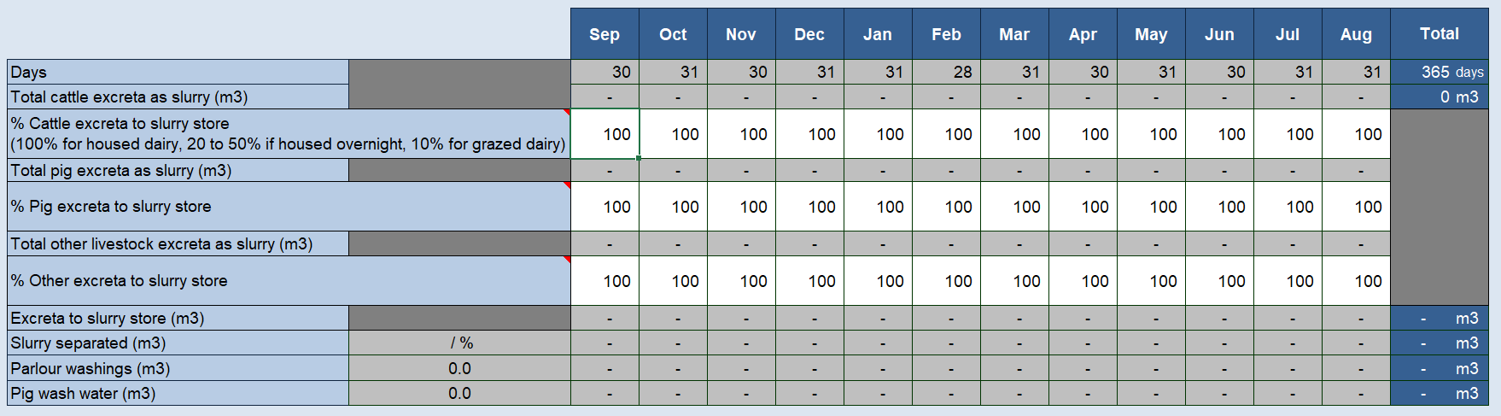
The report then illustrates month-by-month average rainfall figures based on the 1km² in which the slurry store is situated, and it automatically adjusts the figure to account for years when it is wetter than usual.
You can use your own rainfall data; the tool will automatically make an adjustment of +25% to increase the monthly totals (expressed in mm) to account for years when it is wetter than usual.
You must then choose which months’ storage is required by clicking in the box for each month and then choosing ‘Yes’ or ‘No’, being mindful that slurry should not be spread when there is no crop or soil need.
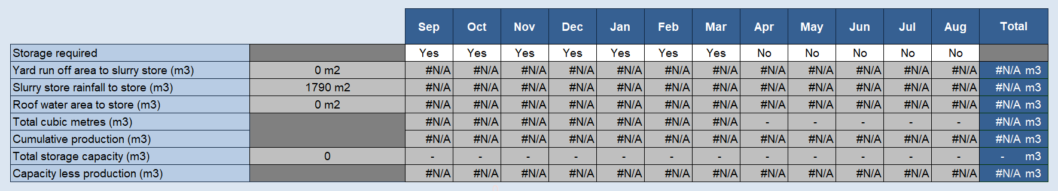
You will then see a breakdown on a month-by-month basis of:
- The yard run-off that goes to slurry store
- The slurry store rainfall that goes to store
- Roof water that goes to slurry store
- Total production
- Cumulative production
- Total storage capacity
- Capacity less production
The capacity less production figure assumes that the store is empty at the beginning of the storage period. Storage requirements may differ depending on which legislative jurisdiction covers your farm.
It only carries out the calculation if the ‘Storage Required’ box is set to ‘Yes’.
Where there is insufficient storage capacity, you should consider alternative options, e.g. you could divert all roof water. The report provides some information on cost vs benefit and possible actions to consider, which are based on the data you entered.
The net benefit of diverting rainwater is based on the total area of roof water and dirty yard area (either with or without water harvest), the construction cost of the storage volume required and the spreading cost of the resulting slurry.
Once you have established the current situation, you can save this as ‘existing’ and then consider alternative strategies, which can then be examined using the slurry wizard and saved as alternative options.
You can export, print and share your slurry report by selecting the ‘Export worksheets to PDF’ button.

More about slurry on the AHDB website:
Slurry wizard
Slurry storage

